Main Concept:

‘this’ is the object that **owns** the method in a method invocation.

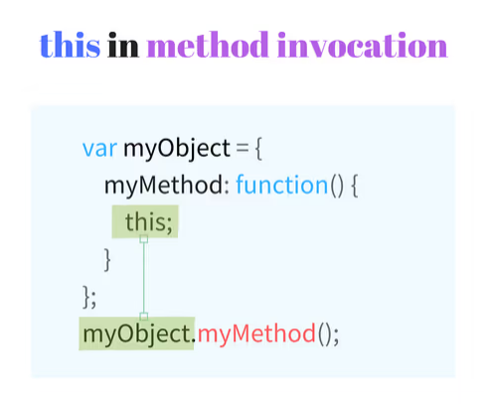

Example Code:

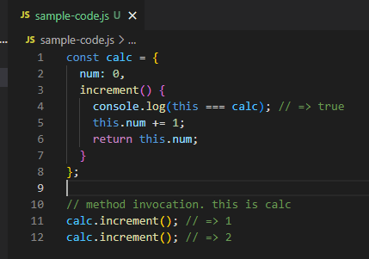

When JS Object inherits a method from its prototype

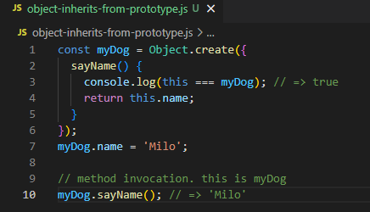

‘this’ is equal to myDog and not Object prototype

ES2015 class syntax

* Method invocation context is also the instance/object itself

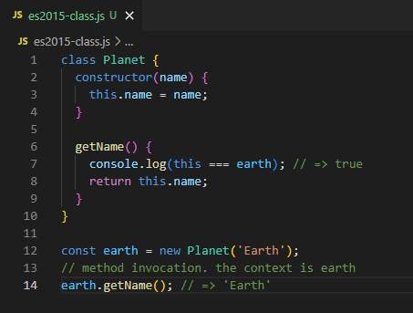

‘this’ refers to earth since it is the object/instance before the dot (.)